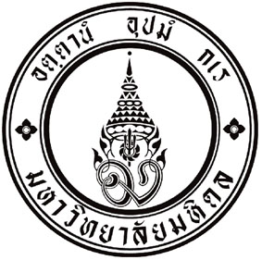

CMMU Ph.D. Scholarship Application Form

- Application information
Name-Surname_______________________________________
Birth date (dd/mm/yyyy)___________________ Age______ years
Application No.____________ Nationality___________________
Research Interest
__________________________________________________________________________________________________________________________________________
- CMMU Ph.D. Entrance Exam Score.
**Remark: Please complete this section if you could provide your scores. Otherwise, leave them blank.
TOEFL score:____________________ Date of taken(dd/mm/yyyy)_____________
GMAT score:_____________________ Date of taken(dd/mm/yyyy)_____________
CMMU English Test score:____________________ (complete by CMMU)
CMMU Analytical score:______________________ (complete by CMMU)
- Education background
I graduated bachelor degree in__________________________________
From University__________________ Year of graduation____________
GPA____________ Honor awarded 1st class 2nd class 3rd class
I graduated my master degree in________________________________
From University__________________ Year of graduation____________
GPA____________
Professional Achievements:
_______________________________________________________________________________________________________________________________________________________________________________________________________________
- Full-Time studentship available:
If I got scholarship offer, I can be a full time student and work according to CMMU Ph.D. Scholarship Guideline. Yes No
Further information:
Please attach any supporting evidence, if you believe that the additional evidence will support your scholarship application.

I hereby certify that all information above is true.

(sign)_________________________________________
Name-Surname_________________________________
Date( dd/mm/yyyy)______________________________

Attachment checklist
Completed CMMU Ph.D. application form and required documents
Statement of purpose: (1 page single space) why you should get this scholarship
2 Academic References: support your scholarship application.
Full CV: (Maximum of 4 pages single space)

